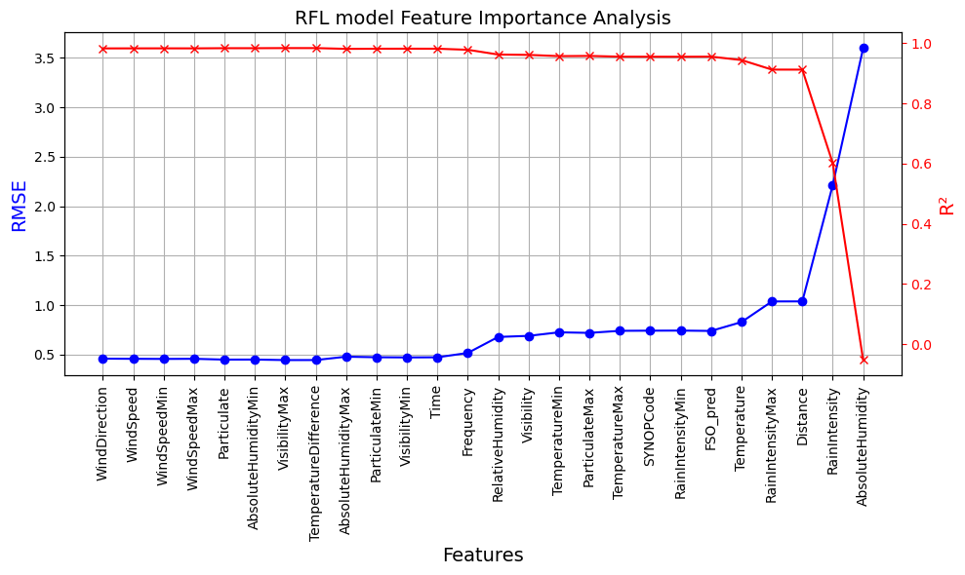

‘RFL_Att’:[‘FSO_pred’,’Temperature’,’RainIntensityMax’,’Distance’,’RainIntensity’,’AbsoluteHumidity’]

‘FSO_Att’:[‘TemperatureDifference’,’Time’,’VisibilityMax’,’ParticulateMax’,’RelativeHumidity’,’AbsoluteHumidity’,’TemperatureMin’,’Particulate’,’RFL_pred’,’VisibilityMin’,’ParticulateMin’,’Temperature’,’Visibility’,’Distance’]

